3.1 Main Question (สำหรับแสดงข้อสอบ)

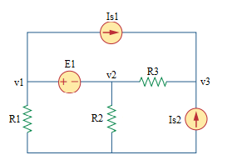

Given *IS*1 = 6 A, *IS*2 = 3 A, V*S* = 5 V, *R*1 = 10 Ω, *R*2 = 5 Ω, *R*3 = 2 Ω.

Find

Variables (สำหรับเขียนโค้ดเพื่อหาคำตอบ)

Random variables

IS1 = {1:10}; IS2 = {1:10}; VS= {1:10};

R1 = {1:10}; R2 = {1:10}; R3 = {1:10};

Global variables

#IS1 = 6; IS2 = 3; VS = 5; R1 = 10; R2 = 5; R3 = 2;

G11 = 1/R1; G12 = 1/R2+1/R3; G13 = -1/R3;

G21 = 1; G22 = -1; G23 = 0;

G31 = 0; G32 = -1/R3; G33 = 1/R3;

I1 = -IS1; I2 = VS; I3 = IS1+IS2;

D = G11\*G22\*G33+G12\*G23\*G31+G13\*G21\*G32-G31\*G22\*G13-G32\*G23\*G11-G33\*G21\*G12;

D1 = I1\*G22\*G33+G12\*G23\*I3+G13\*I2\*G32-I3\*G22\*G13-G32\*G23\*I1-G33\*I2\*G12;

D2 = G11\*I2\*G33+I1\*G23\*G31+G13\*G21\*I3-G31\*I2\*G13-I3\*G23\*G11-G33\*G21\*I1;

D3 = G11\*G22\*I3+G12\*I2\*G31+I1\*G21\*G32-G31\*G22\*I1-G32\*I2\*G11-I3\*G21\*G12;

V1 = D1/D; V2 = D2/D; V3 = D3/D;

Part (กรอกคำตอบ)

1. *v*1 = V1 = 13.33 V

2. *v*2 = V2 = 8.33 V

3. *v*3 = V3 = 26.33 V

3.2 Main Question (สำหรับแสดงข้อสอบ)

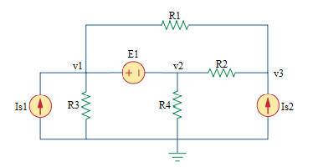

Given *Is*1 = 6 A, *Is*2 = 3 A, E1 = 5 V, *R*1 = 2 Ω, *R*2 = 1 Ω, *R*3 = 4 Ω, *R*4 = 4 Ω.

Find

Variables (สำหรับเขียนโค้ดเพื่อหาคำตอบ)

Random variables

IS1 = {1:10}; IS2 = {1:10}; E1 = {1:10};

R1 = {1:10}; R2 = {1:10}; R3 = {1:10}; R4 = {1:10};

Global variables

#IS1 = 6; IS2 = 3; E1 = 5; R1 = 2; R2 = 1; R3 = 4; R4 = 4;

G11 = 1/R1+1/R3; G12 = 1/R2+1/R4; G13 = -1/R1-1/R2;

G21 = 1; G22 = -1; G23 = 0;

G31 = -1/R1; G32 = -1/R2; G33 = 1/R1+1/R2;

I1 = IS1; I2 = E1; I3 = IS2;

D = G11\*G22\*G33+G12\*G23\*G31+G13\*G21\*G32-G31\*G22\*G13-G32\*G23\*G11-G33\*G21\*G12;

D1 = I1\*G22\*G33+G12\*G23\*I3+G13\*I2\*G32-I3\*G22\*G13-G32\*G23\*I1-G33\*I2\*G12;

D2 = G11\*I2\*G33+I1\*G23\*G31+G13\*G21\*I3-G31\*I2\*G13-I3\*G23\*G11-G33\*G21\*I1;

D3 = G11\*G22\*I3+G12\*I2\*G31+I1\*G21\*G32-G31\*G22\*I1-G32\*I2\*G11-I3\*G21\*G12;

V1 = D1/D; V2 = D2/D; V3 = D3/D;

Part (กรอกคำตอบ)

1. *V*1 = V1 = 20.5 V

2. *V*2 = V2 = 15.5 V

3. *V*3 = V3 = 19.166 V

3.3 Main Question (สำหรับแสดงข้อสอบ)

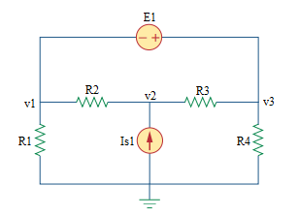

Given *Is*1 = 5 A, *E1* = 10 V, *R*1 = 10 Ω, *R*2 = 5 Ω, *R*3 = 10 Ω, *R*4 = 8 Ω.

Find

Variables (สำหรับเขียนโค้ดเพื่อหาคำตอบ)

Random variables

IS1 = {1:10}; E1= {1:10};

R1 = {1:10}; R2 = {1:10}; R3 = {1:10}; R4 = {1:10};

Global variables

#IS1 = 5; E1 = 10; R1 = 10; R2 = 5; R3 = 10; R4 = 8;

G11 = -1; G12 = 0; G13 = 1;

G21 = -1/R2; G22 = 1/R2+1/R3; G23 = -1/R3;

G31 = 1/R1+1/R2; G32 = -1/R2-1/R3; G33 = 1/R3+1/R4;

I1 = E1; I2 = IS1; I3 = 0;

D = G11\*G22\*G33+G12\*G23\*G31+G13\*G21\*G32-G31\*G22\*G13-G32\*G23\*G11-G33\*G21\*G12;

D1 = I1\*G22\*G33+G12\*G23\*I3+G13\*I2\*G32-I3\*G22\*G13-G32\*G23\*I1-G33\*I2\*G12;

D2 = G11\*I2\*G33+I1\*G23\*G31+G13\*G21\*I3-G31\*I2\*G13-I3\*G23\*G11-G33\*G21\*I1;

D3 = G11\*G22\*I3+G12\*I2\*G31+I1\*G21\*G32-G31\*G22\*I1-G32\*I2\*G11-I3\*G21\*G12;

V1 = D1/D; V2 = D2/D; V3 = D3/D;

Part (กรอกคำตอบ)

1. *V*1 = V1 = 16.66 V

2. *V*2 = V2 = 36.66 V

2. *V*3 = V3 = 26.66 V

3.4 Main Question (สำหรับแสดงข้อสอบ)

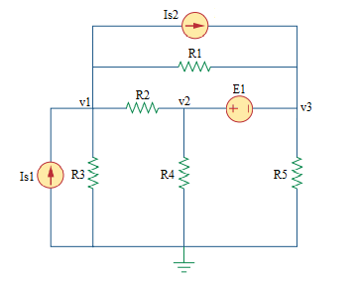

Given *Is*1 = 4 A, *Is*2 = 5 A, *E1* = 10 V, *R*1 = 10 Ω, *R*2 = 8 Ω, *R*3 = 6 Ω, *R*4 = 4 Ω, *R*5 = 5 Ω.

Find

Variables (สำหรับเขียนโค้ดเพื่อหาคำตอบ)

Random variables

IS1 = {1:10}; IS2 = {1:10}; E1 = {1:10};

R1 = {1:10}; R2 = {1:10}; R3 = {1:10}; R4 = {1:10}; R5 = {1:10};

Global variables

#IS1 = 4; IS2 = 5; E1 = 10; R1 = 10; R2 = 8; R3 = 6; R4 = 4; R5 = 5;

G11 = 1/R1+1/R2+1/R3; G12 = -1/R2; G13 = -1/R1;

G21 = -1/R1-1/R2; G22 = 1/R2+1/R4; G23 = 1/R1+1/R5;

G31 = 0; G32 = 1; G33 = -1;

I1 = IS1-IS2; I2 = 0; I3 = E1+IS2;

D = G11\*G22\*G33+G12\*G23\*G31+G13\*G21\*G32-G31\*G22\*G13-G32\*G23\*G11-G33\*G21\*G12;

D1 = I1\*G22\*G33+G12\*G23\*I3+G13\*I2\*G32-I3\*G22\*G13-G32\*G23\*I1-G33\*I2\*G12;

D2 = G11\*I2\*G33+I1\*G23\*G31+G13\*G21\*I3-G31\*I2\*G13-I3\*G23\*G11-G33\*G21\*I1;

D3 = G11\*G22\*I3+G12\*I2\*G31+I1\*G21\*G32-G31\*G22\*I1-G32\*I2\*G11-I3\*G21\*G12;

V1 = D1/D; V2 = D2/D; V3 = D3/D;

Part (กรอกคำตอบ)

1. *V*1 = V1 = -3.1579 V

2. *V*2 = V2 = 5.614 V

3. *V*3 = V3 = -9.386 V

8.5 Main Question (สำหรับแสดงข้อสอบ)

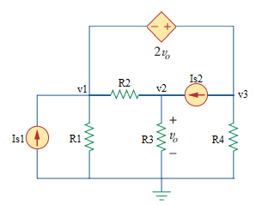

Given *Is*1 = 5 A, *Is*2 = 8 A, *R*1 = 4 Ω, *R*2 = 2 Ω, *R*3 = 8 Ω, *R*4 = 5 Ω.

Find

Variables (สำหรับเขียนโค้ดเพื่อหาคำตอบ)

Random variables

IS1 = {1:10}; IS2 = {1:10};

R1 = {1:10}; R2 = {1:10}; R3 = {1:10}; R4 = {1:10};

Global variables

#IS1 = 5; IS2 = 8;

#R1 = 4; R2 = 2; R3 = 8; R4 = 5;

G11 = 1/R1+1/R2; G12 = -1/R1; G13 = 1/R4;

G21 = -1/R1; G22 = 1/R2+1/R3; G23 = 0;

G31 = -1; G32 = -2; G33 = 1;

I1 = IS1-IS2; I2 = IS2; I3 = 0;

D = G11\*G22\*G33+G12\*G23\*G31+G13\*G21\*G32-G31\*G22\*G13-G32\*G23\*G11-G33\*G21\*G12;

D1 = I1\*G22\*G33+G12\*G23\*I3+G13\*I2\*G32-I3\*G22\*G13-G32\*G23\*I1-G33\*I2\*G12;

D2 = G11\*I2\*G33+I1\*G23\*G31+G13\*G21\*I3-G31\*I2\*G13-I3\*G23\*G11-G33\*G21\*I1;

D3 = G11\*G22\*I3+G12\*I2\*G31+I1\*G21\*G32-G31\*G22\*I1-G32\*I2\*G11-I3\*G21\*G12;

V1 = D1/D; V2 = D2/D; V3 = D3/D;

Part (กรอกคำตอบ)

1. *V*1 = V1 = -4.8713 V

2. *V*2 = V2 = 10.8515 V

3. *V*3 = V2 = 16.8317 V